**Building an automation framework with the below asks**

1. Writing user stories using Jira
2. Recording the test results with Zephyr and user stories with JIRA

**Requirement specification:**

The application <http://elearningm1.upskills.in/> is built by your company, and the manual tester is called for testing in English language on the home page. The manual tester has tested and has given below write up. The company wants to automate the work done by manual tester, and generate relevant report for auditing.

The application on the home age helps to register with the signup option provided, upon entering the details of mandatory fields like firstname, lastname, e-mail, Username, pass, Confirm password, and clicking on Register button on same page. The message is shown on the next page of the username which was entered in the first page, and it is confirmed it is registered as on the screen a confirmation message is shown as below

“Dear FirstName, LastName”,

Your personal settings have been registered.

And on the top right corner a dropdown is shown, upon clicking it (shown below)

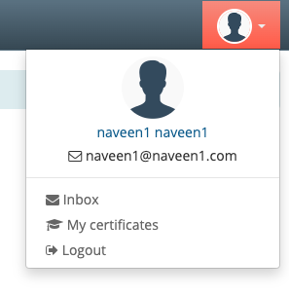

And its validated the email which is entered. And the tester has validated to send an message to other user in the system with the “Compose” option in the home page. By clicking Compose, a new windows is opened, and tester entered as shown below

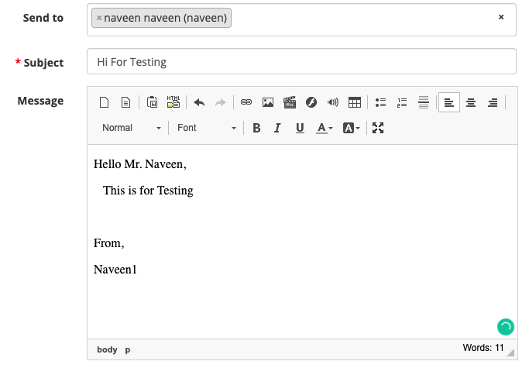

And finally clicks on send message, the acknowledgement is shown.

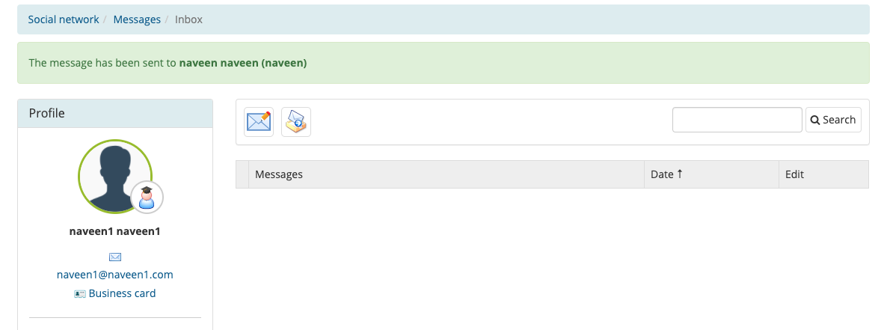

You are asked to convert the manual cases to automate with the below said steps.

1. Understand the steps given and replicate the same.
2. Create appropriate user stories in JIRA under Epic – eLearning Management
3. Install Zephyr plugin in your account
4. Add all the test cases with Given When Then cases which are written
5. Add test cases to Test Cycle
6. Generate the reports from the zephyr and share.
7. Test Summary Report and Share.
8. Test Metrics Report.